**MINI PROJECT – II (2020-21)**

# HOTEL RESERVATION MANAGEMENT APP

**SALESFORCE**

**SYNOPSYS**



**Institute of Engineering & Technology**

# SUBMITTED TO- SUBMITTED BY-

MR.PANKAJ SHARMA UTKARSH VIMAL (171500364)

ACKNOWLEDGEMENT

We take this opportunity to express our sincere gratitude to all those who helped us in various capacities in undertaking this project and devising the report. We are privileged to express our sense of gratitude to our respected teacher Mr. PANKAJ SHARMA SIR whose unparalleled knowledge, moral fiber and judgment along with his know-how, was an immense support in completing the project.

We are also grateful to DR.ANAND SINGH JALAL SIR ,the Head of Department, Information Technology, for the brainwave and encouragement given.

We take this opportunity also to thank our friends and contemporaries for their cooperation and compliance.

UTKARSH VIMAL

(171500364)

# Table of Contents

-

* Title of the project.
* Introduction and objectives of the Project.
* Software and Hardware requirements..
* Project description
* Analysis (DFDs, ER Diagrams, Class Diagrams etc.)
* Sreenshots
* Bibliography

# INTRODUCTION

-

This is a Project work undertaken in context of partial fulfillment of Btech Computer Science .I have tried my best to make the complicated process of Online Hotel Management System as simple as possible using Structured & Modular technique & Menu oriented interface. I have tried to design the software in such a way that user may not have any difficulty in using this package & further expansion is possible without much effort. Even though I cannot claim that this work to be entirely exhaustive, the main purpose of my exercise is perform each Employee’s activity in computerized way rather than manually which is time suming.

I am confident that this software package can be readily used by non- programming personal avoiding human handled chance of error. This project is used by two types of users-

1. Online Users.
2. Administrator (management of the Hotel).

Administrator can maintain daily updates in the hotel records. Administrator is must bean authorized user. He can further change the password. There is the facility for password recovery, logout etc. The main aim of the entire activity is to automate the process of day to day activities of Hotel like Room activities, Admission of a New Customer, Assign a room according to customer’s demand, checkout of a computer and releasing the room and finally compute the bill etc. The limited time and resources have restricted us to incorporate, in this project, only a main activities that are performed in a HOTEL Management System, but utmost care has been taken to make the system efficient and user friendly. “HOTEL Management System” has been designed to computerized the following functions that are performed by the system:

Room Detail Functions Opening a New Room Modification to room assigned Check-in and check-out Detail Functions Admission of New customer Check-out of customer Room assigning related to customer’s need. Statement of Customer Details Check-in customer Check-out customer Room Details Total number of Customers in the Hotel Individual customer Report.

# OBJECTIVE

-

During the past several decades personnel function has been transformed from a relatively obscure record keeping staff to central and top level management function. There are many factors that have influenced this transformation like technological advances, professionalism, and general recognition of human beings as most important resources.

* A computer based management system is designed to handle all the primary information required to calculate monthly statements. Separate database is maintained to handle all the details required for the correct statement calculation and generation.
* This project intends to introduce more user friendliness in the various activities such as record updation, maintenance, and searching. The searching of record has been made quite simple as all the details of the customer can be obtained by simply keying in the identification of that customer.
* Similarly, record maintenance and updation can also be accomplished by using the identification of the customer with all the details being automatically generated. These details are also being promptly automatically updated in the master file thus keeping the record absolutely up-to-date.The entire information has maintained in the database or Files and whoever wants to retrieve can’t retrieve, only authorization user can retrieve the necessary information which can be easily be accessible from the file.
* The main objective of the entire activity is to automate the process of day to day activities of Hotel like:
  1. Room activities,
  2. Admission of a New Customer,
  3. Assign a room according to customer’s demand,
  4. Checkout of a computer and releasing the room
  5. Finally compute the bill etc.
  6. Packages available.
  7. Advance online bookings.
  8. Online Cancellation.
  9. List of Regular customers.

# ---Some more features---

* System Connectivity
* No data duplication
* No Paper Work Required
* Time Efficient
* Cost Efficient
* Automatic data validation

ADVANTAGE

-

* + I have designed the given proposed system in the JSP to automate the process of Hotels. This project is useful for the authorities which keep track of all the users registered in a particular state .The authority can add hotel packages, room details, availability of rooms, online booking etc.
  + The following steps that give the detailed information of the need of proposed system are:
  + Performance: During past several decades, the records are supposed to be manually handled for all activities. The manual handling of the record is time consuming and highly prone to error. To improve the performance of the Hotel Management System, the computerized system is to be undertaken. This project is fully computerized and user friendly even that any of the members can see the report and status of the company.
  + Efficiency: The basic need of this website is efficiency. The website should be efficient so that whenever a new user submits his/her details the website is updated automatically. This record will be useful for other users instantly.
  + Control: The complete control of the project is under the hands of authorized person who has the password to access this project and illegal access is not supposed to deal with. All the control is under the

administrator and the other members have the rights to just see the records not to change any transaction or entry.

* + Security: Security is the main criteria for the proposed system. Since illegal access may corrupt the database. So security has to be given in this project.

# Motivation

To meet the solution of manage the students records in easy way and in proper Manner . we can find the record of students by this way very easily.

# FUTURE PROSPECTS

* + The Hotel Reservation System can be enhanced to include some other functionality like management of Parties.
  + Online other facility functionality can be added.
  + Can evolve as an online service.
  + Functionality of chat and messages can be added.
  + Online room bookings functionality can be added.

# REQUIREMENTS

Software Requirements:

* + Salesforce
  + Salesforce platform
  + Microsoft Windows or Linux

# Hardware Requirements:

* + Intel Pentium IV processor or equivalent or higher
  + 512 MB Ram or Higher
  + 20 GB HDD or Higher
  + Network Connectivity

# Technology:

* + Cloud
  + Salesforce

P a g e | **13**

**Cloud Computing**

Cloud computing is usually defined as storing and managing the data over the cloud, rather than a local server. Cloud computing is easy to understand. All applications are developed and run in the web browser. Using the internet connection, users and developers will have access to whole applications thus eliminating the complexity and overhead of the maintain environment.

Unlike traditional business applications which are complicated, expensive and need experts to install, run, update and secure, cloud computing can be accessed anywhere with an online connection. In traditional systems, the entire infrastructure must work together. For such type of seamless interaction, and for the smooth run of the system, a constant maintenance is always required. With cloud computing, there is no necessity to invest money in acquiring and supporting hardware and software infrastructure, thus decreasing the potential cost for users and developers.

The main impact of cloud computing is on the responsiveness of IT systems. With the cloud computing environment, we can add users and developers instantly, and the applications can be deployed rapidly into the cloud which reduces the user request response time. As the complexity of the of the internal systems is removed, the organization can speed up the entire IT process.

P a g e | **14**

**Cloud Computing**

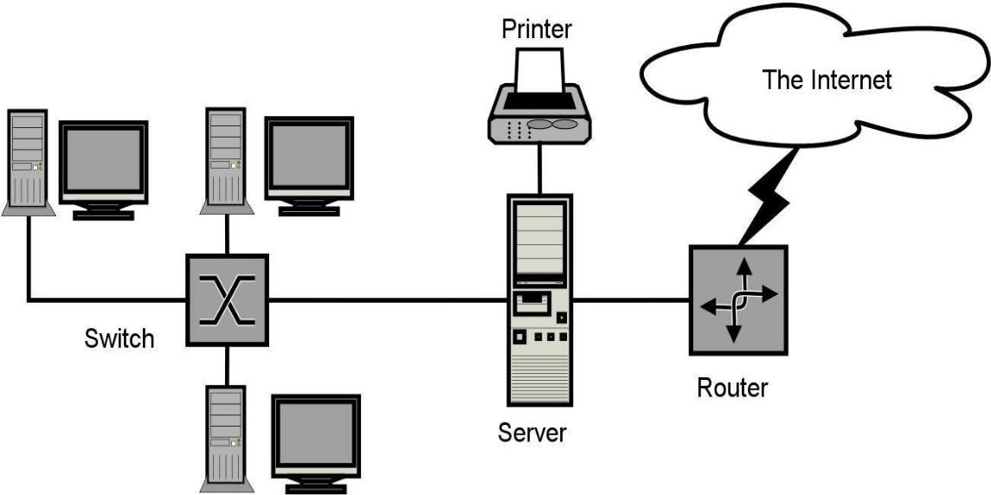

P a g e | **15**

**1.1 Service Models of Cloud Computing**

**1.11 Software as a Service (SaaS)**

The end user can access the application which is developed by the provider on a cloud framework. The developed applications are available from different customer devices through interfaces like a web program or a program interface. Cloud infrastructure, servers, networks, storage and operating systems cannot be managed or controlled by the customer.

Cloud application services represent the increasing cloud market. Software as a service utilizes the internet to deploy the applications overseen by the vendor and whose interface will be able to access on the customer side. Many of the applications developed using SaaS will run in a web browser by using some plugins. There will not be need of any download or establishments.

The major applications which are developed using SaaS are healthcare related applications, client relationship administrations, incorporate email, and collaboration. Some of the costly ventures which are not able to considered as software vendors started using SaaS to get the upper hand and gain income.

**1.12 Platform as a Service(PaaS)**

The Client can deploy onto the cloud infrastructure developed by the customers with the help of libraries, tools, services and the programming languages which are supported by the client. The underlying infrastructure of cloud and storage, servers, network or operating systems cannot be managed or controlled by the Customer .

Cloud platform services can be utilized for applications and their advancements when cloud segments are given to programming. Developers can be able to pick

P a g e | **16**

the structure using PaaS where the applications can be expanded to create or modify. The testing and deployment of applications become easy and fast if the PaaS is used.

Enterprise PaaS gives a self-service portal to programming engineers for overseeing computing infrastructure from information technology operations. Scalability, Software as a service enablement and multi-occupancy can be acquired by the applications using PaaS. The coding fundamental measure will be decreased for the enterprises using PaaS and the application will be converted to a hybrid model [14].

**1.13 Infrastructure as a Service (IaaS**)

The customer can arrange systems, storage, processing and other essential computing resources in which the client can run and send arbitrary software like applications and operating systems. The hidden cloud infrastructure is not controlled or overseen by the customer but rather he can control over operating systems, storage, servers and network.

P a g e | **17**

Cloud infrastructure services, referred to as IaaS, are models beneficial for overseeing and observing remote data center frameworks such as organizing, processing, stockpiling and networking services. With the help of IaaS, clients will get utility billing and power benefits.

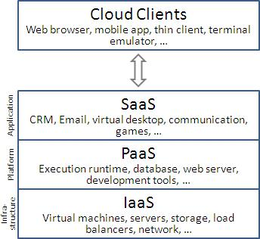

**Figure 2: Service Models of Cloud Computing [9]**

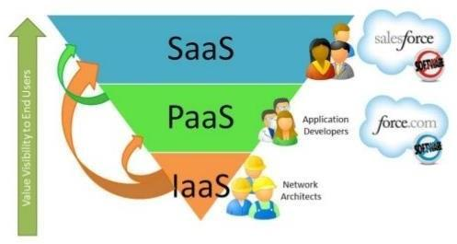

**Figure 3: Service Models [10]**

P a g e | **18**

**Salesforce**

**2.1 Introduction to Salesforce**

Salesforce is one of the world's prime cloud computing companies and number one on-demand customer relationship management(CRM). Salesforce does not need any software installation or hardware or any infrastructure like servers. All we need to access Salesforce is the internet. This empowers even the most non-techie individuals to be able to use the system and configure it as per their needs.

Established as Salesforce.com(SFDC) and its customer relationship management (CRM) service and then divided into different sectors like sales cloud, service cloud, community cloud, analytics cloud, data cloud, marketing cloud, app cloud, and so on.

Since Salesforce coordinates well with all the platforms and supports all major OS and mobile devices, it is anything but difficult to utilize Salesforce outside of the workplace, thus helps to improve productivity.

**2.2 The Architecture of Salesforce**

Salesforce has a multi-tenant Architecture. Multi-tenancy is the fundamental technology utilized as a part of the cloud to share its resources safely and cost effectively. It's much the same as bank services where various tenants cost-efficiently share a common infrastructure yet safely and with most protection from other tenants. A cloud utilizes multi-tenant infrastructure to share its assets safely among different applications and occupants (organizations, associations, and so on) that use the cloud. Some clouds utilize virtualization-based architecture to confine occupants; others utilize custom software architecture to take care of business. The multi-tenant outline of a cloud service can dramatically affect the application delivery and the profitability of IT organization .

P a g e | **19**

Multi-Tenancy

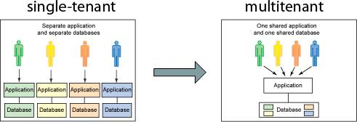

P a g e | **20**

**Salesforce Multiple View Controller (MVC)**

MVC is a design pattern which separates business logic from interface logic i.e. it separates the graphical interface displayed to the user with the code that manages the user actions**.**

In Salesforce, using SFDC visual force, we can write VIEW pages which are very similar to java servlets page(JSP) pages. Each visualforce(VF) page is corelated with a controller. The controller and model classes can be written using Apex language. In SFDC, controller part comprises of workflows, triggers, Apex classes and model layer comprises of fields, relationships, objects and View layer comprises of Tabs, page layouts, VF pages.

SFDC MVC mainly consists of three modules namely Model, View and Controller.

1. Model: Here we represent what schema and data the Salesforce used for the system representation and So objects are a model, as every entity is mapped to some subject in Salesforce.
2. View: Here we represent how data and schema and visual force are used to present data to users.
3. Controller: Here we use controllers and interface actions to perform actions when the user interacts with visual force.

P a g e | **21**

**Salesforce MVC**

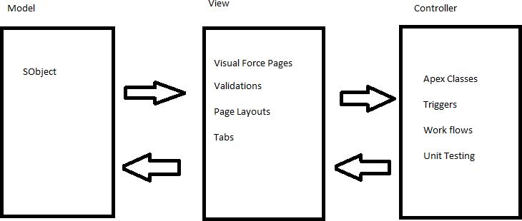

P a g e | **22**

**Different editions of Salesforce**

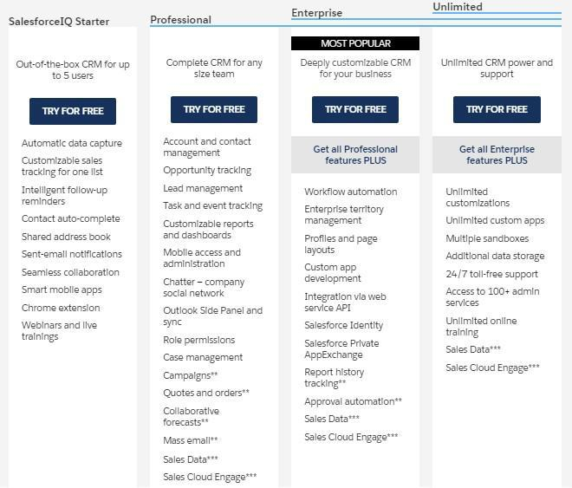

**Figure 6: Different Versions of Salesforce**

P a g e | **23**

**System Overview**

Salesforce.com allows administrators to configure and design systems for complex implementations. Salesforce combines the power of configuration and custom development in its platform i.e. Force.com Platform. This platform user can make use of custom code, workflows rules, approval processes to implement their business logic and they can integrate the data with other applications, generate reports and do the analytics within no time. The Salesforce CRM model is used in organizations for interactions like emails, meetings, events with customers and also for prospects like sales, marketing, and support.

With Force.com, we can run business in the mobile using the Salesforce1 app. We can build and optimize the apps for mobile using HTML 5 and UI framework and it supports all devices with just one code base [5]. Salesforce1 downloadable app can be installed from the App store or Google play on a mobile device.

P a g e | **24**

**Salesforce Mobile App**

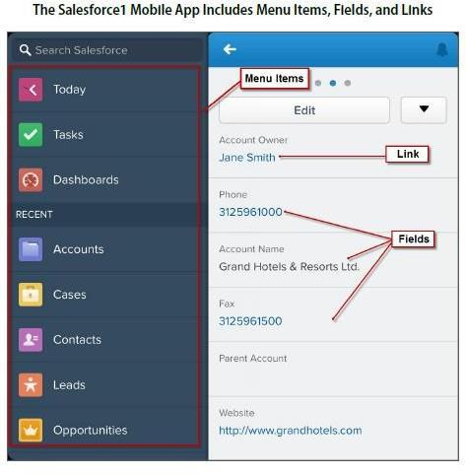

P a g e | **25**

Salesforce even has an app marketplace called AppExchange where we can find pre-built business applications. AppExchange offers thousands of verified and secured apps built by others or we can develop our own app and sell it here. It’s quite similar to the App store and the play store.

Due to its ease of access, ease of use, minimum licensing/proprietary issues, and per user cost, Salesforce becomes a power system from small to large scale industries**.**

**Technologies of Salesforce**

**1) Apex**

Salesforce has a programming language called Apex. It is a case-insensitive, mostly typed object-oriented programming language with syntax identical Java with curly brackets and dot- notation syntax. Apex is used to run programs and procedure in Force.com such as links, buttons, record insertion and so on with visual force custom controllers .

**2) Visualforce**

Visualforce(VF) is a framework for the Force.com platform with tag-based markup language identical to HTML. With the help of Visualforce, custom pages can be created for mobile apps and desktops with the help of with other front-end technologies like HTML, CSS, jquery, and JavaScript. With the Visualforce standard and custom controller features, we can build our own business logic in Apex.

P a g e | **26**

**3) Lighting**

Lightning is a component-based framework for the Salesforce1 mobile app which is built on an open source Aura framework. With the lighting framework, responsive applications can be built easily. The apps build on the Lighting framework is sold or brought on AppExchange.

Lightning App builder for Salesforce is a tool for quick application advancement of responsive web interfaces. This interface takes into account distinctive screens to be assembled given lightning segments. This can be layouts as formats for records or particular applications.

P a g e | **27**

**Benefits of Using Salesforce**

1. **Invest in innovation, not infrastructure**

With Salesforce, we can focus on business rather than the back end as Salesforce add new features and automatic upgrades three times a year. These boundary-pushing work made Salesforce one of Forbes’ Most Innovative Companies.

1. **Don’t stress about the data security**

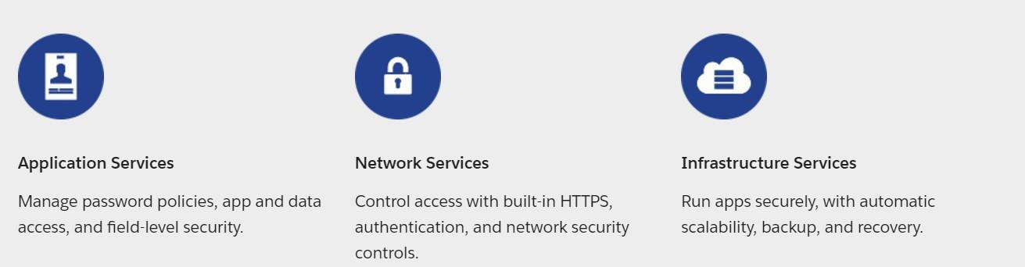

1. **Make Salesforce work the way we want**

Salesforce can be customized to the core to be more agile and productive and the apps can be developed with interfaces with point and click to high-end platforms .

1. **With AppExchange, find Prebuilt applications in minutes**

With industry-specific third party apps, Salesforce can be spread to every division and corporation. These apps are installed by millions of people and are reviewed by thousands. So with trust on the apps, we can focus on extending the business .

1. **Work on one platform where everything works together**

P a g e | **28**

With Salesforce APIs, core technologies and third party tools, we can connect and manage data from any system and from anywhere. Salesforce works in Desktop, Mobile Devices, and iPad too.

**Benefits of Salesforce**

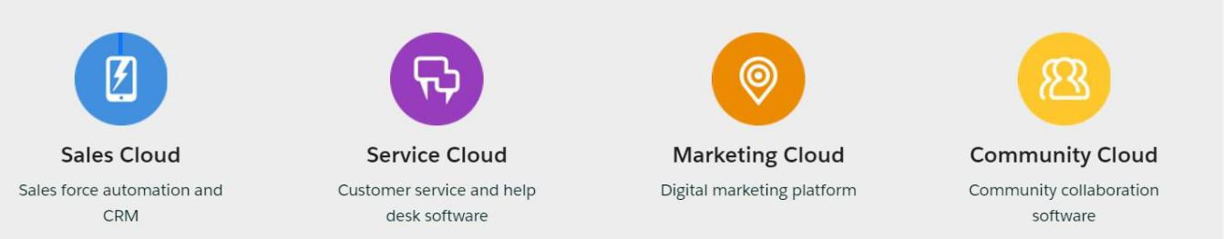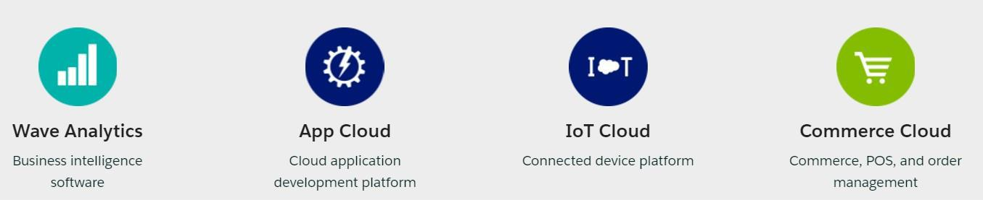

|  |  |  |  |
| --- | --- | --- | --- |
|  |  | P a g e | **29** |  |
|  | **E-R DIAGRAM** |  |  |
| **Hotel** |  | **customer** |  |
| **Room** |  | **Check** |  |
| **information** |  | **-in** |  |
|  |  |  |
|  | **Room** |  |  |
| **Hotel** | **Room** | Customer |  |
| **record** |  |
| **Customer** | **Checkout** | **Room** |  |
|  |  |
|  | **Bill** | **Hotel** |  |
|  | **generation** |  |

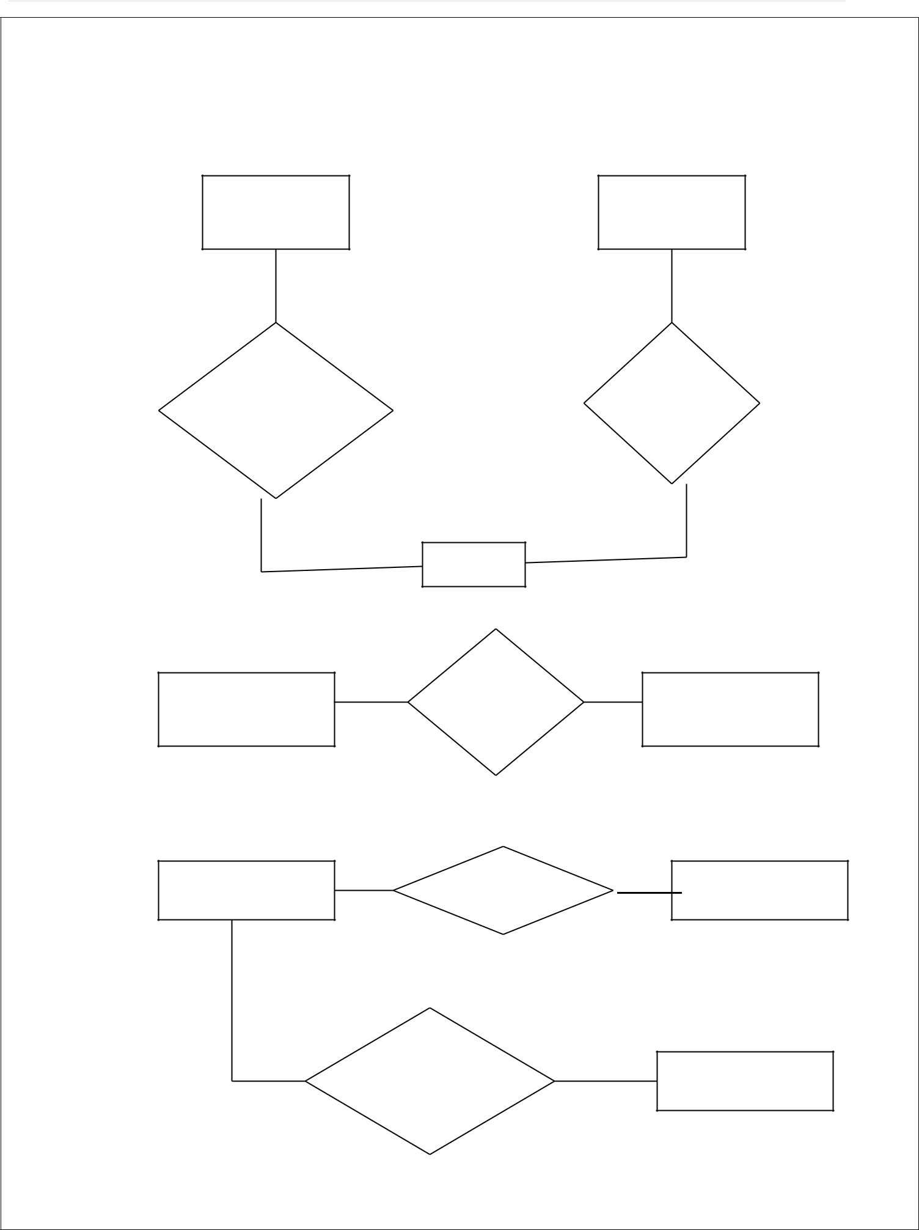

P a g e | **30**

**CONTEXT LEVEL DFD HOTEL**

**MANAGEMENT SYSTEM**

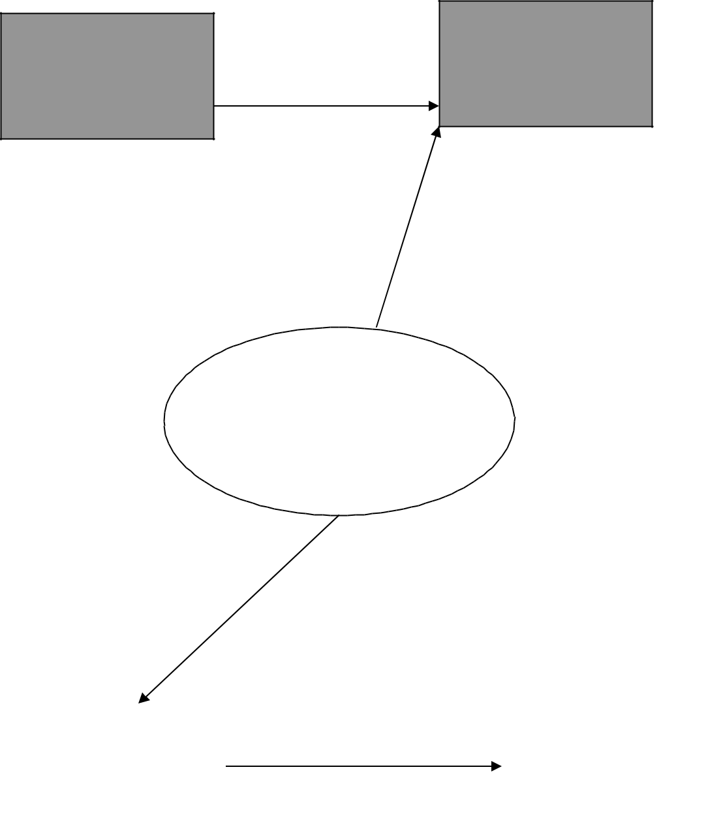

**ROOM** **CUSTOMER**

**HOTEL**

**MANAGEMENT**

**SYSTEM**

|  |  |  |
| --- | --- | --- |
| **CUSTOMER** |  | **PRINT** |
| **CHECKOUT** |  | **DEVICE** |
|  |  |  |

P a g e | **31**

**DATA FLOW DIAGRAM OPENING A NEW ROOM**

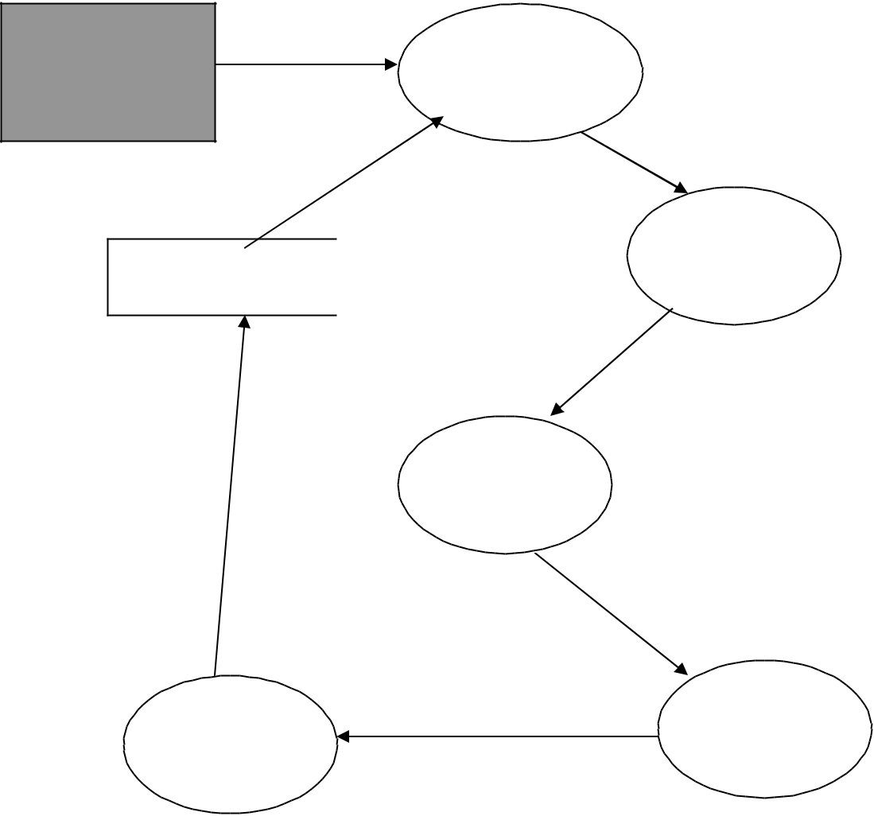

1 Generating

**CUSTOMER** new room

number

1.1 Display

Form

FILE

Process

1.2 Get

|  |  |  |
| --- | --- | --- |
| Update Table | Details |  |
|  |  |

customer Document

1.3

1.4 Open Room Update

P a g e | **32**

**DATA FLOW DIAGRAM CHECK-IN OF A NEW CUSTOMER**

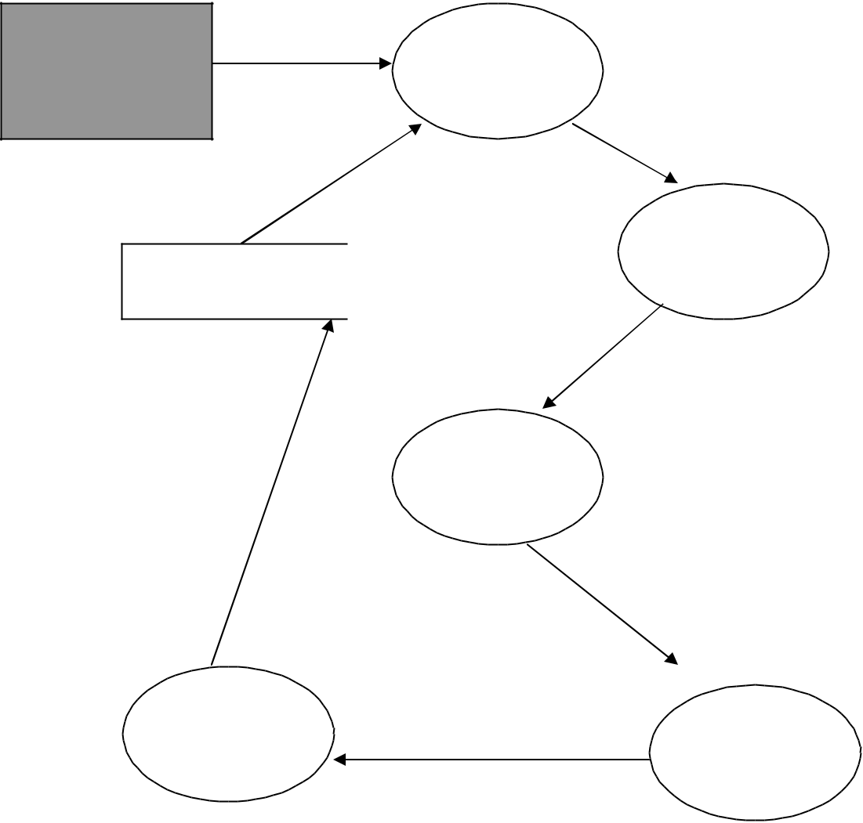

**CUSTOMER**

FILE

Update Table

Customer

Details

1.4

Update

1 Assigning a

new room

number

1.1 Display

Form

Process

1.2 Get

Details

1.3

Assigning a

Room

P a g e | **33**

**DATA FLOW DIAGRAM RECORD MODIFICATION**

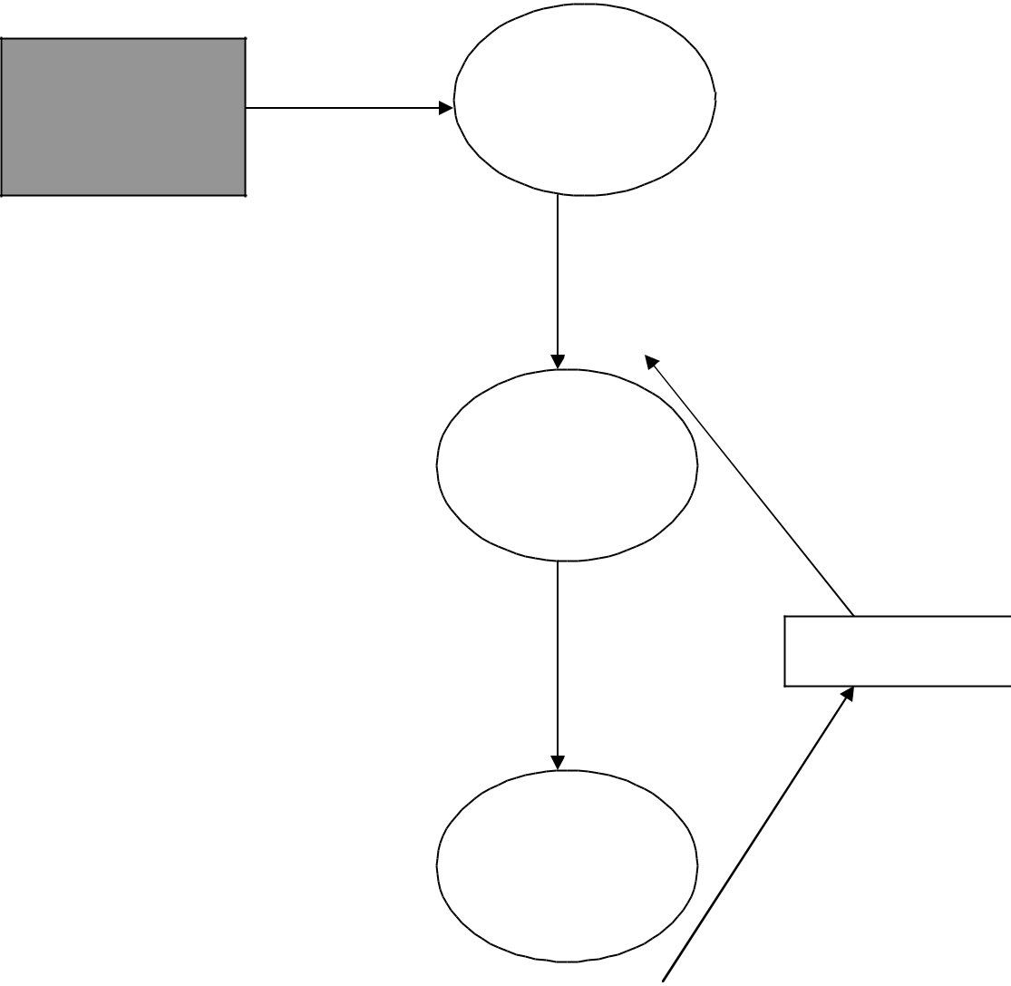

**USER**

1

Read the

customer

room number

Scan Record

2

Show the

Details of

Record

Processing

3

Modify

Details of

Record

FILE

Update

P a g e | **34**

**DATA FLOW DIAGRAM CHECK-OUT OF CUSTOMER**

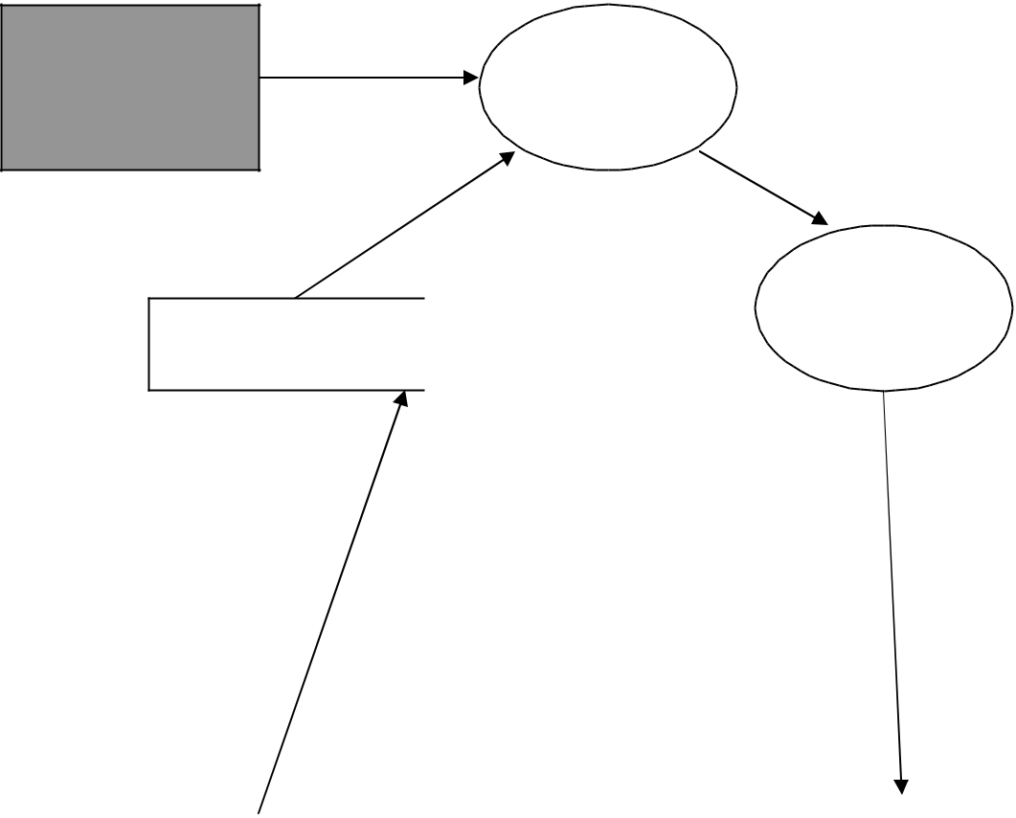

**CUSTOMER**

FILE

1 Scan the

customer

room number

1.1 Display

Form

Process

Update Table

Customer

Details



1.4

Update 1.2 Get Details

|  |  |  |  |  |
| --- | --- | --- | --- | --- |
|  |  |  | P a g e | **35** |  |
| **DATA FLOW DIAGRAM LISTING OF CUSTOMERS** | | | |  |
|  |  | FILE |  |  |
|  |  | Scan Record | |  |
|  | 1 Read the | 2 Select | 3 Copy |  |
| **CUSTOMER** | room | Record | Selected |  |
|  | number | from | Record |  |
|  |  | Database |  |  |
|  |  |  | Processing |  |
|  | 6 Copy |  |  |  |
|  | Selected |  | 4 |  |
|  | Record |  | Compute |  |
|  |  |  | Total |  |
| Processing | |  | Output |  |
|  |  |  |  |
|  |  | 5 Select |  |  |
|  |  | Record |  |  |
|  | 7 |  | 8 |  |
|  |  | Generate |  |
|  | Compute |  |  |
|  |  | Total List |  |
|  | Bill |  |  |
|  | Final Output |  |  |
|  |  |  |  |
|  |  |  | To Screen/Printer |  |
|  |  |  | **OUTPUT** |  |
|  |  |  | **UNIT** |  |

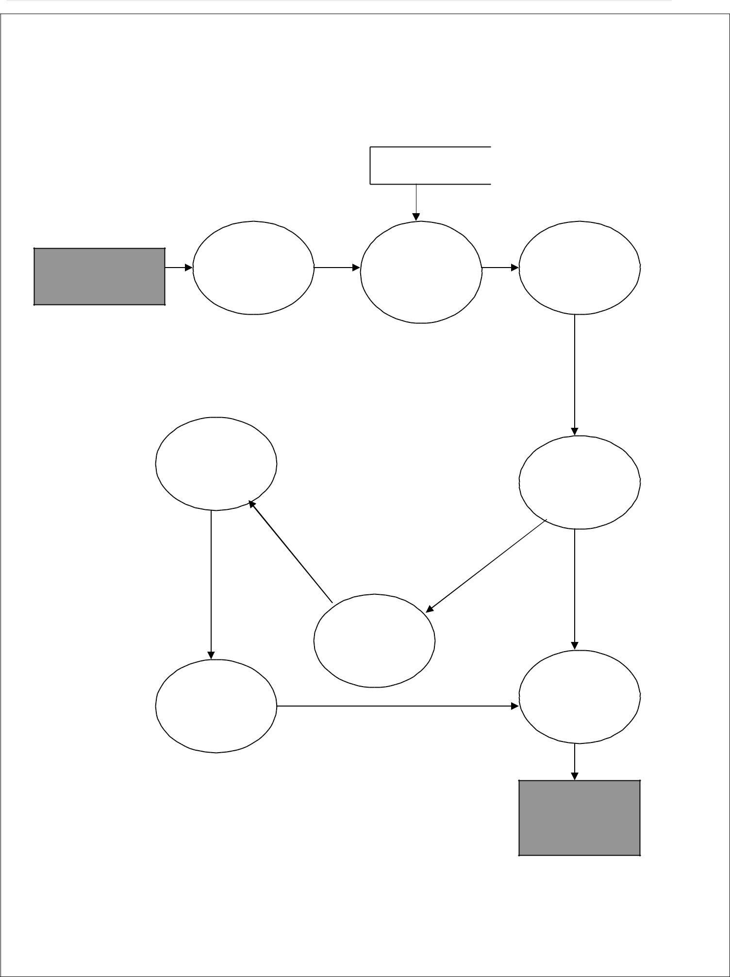

P a g e | **36**

**DATA FLOW DIAGRAM GENERATING BILL OF CUSTOMER**

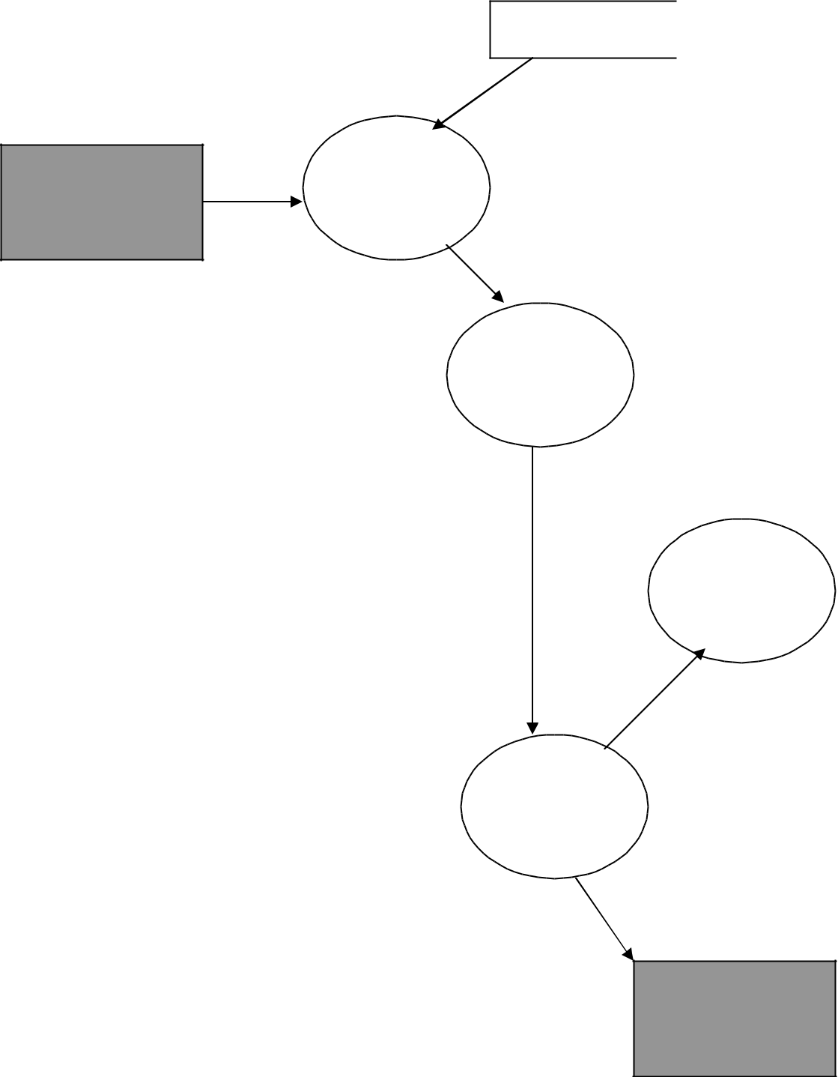

**MANAGE**

**EMENT**

FILE

Scan RoomNo

1

Read room

number

2 Check for

check out of

customer

Update

|  |  |  |
| --- | --- | --- |
| Processing | 4 |  |
| Close |  |
|  |  |
|  | Database |  |

3

Compute

Bill

Cash

**CUSTOMER**

P a g e | **37**

**DATA FLOW DIAGRAM LIST OF ALL RECORDS**

**EMENT**

1. Copy Selected Record

Processing

7

Compute

bill

|  |  |  |
| --- | --- | --- |
|  | FILE |  |
|  |  |  |
|  | Scan All Record | |
| 1 | 2 Select | |
| Read the | Record | |
| Request | from File | |

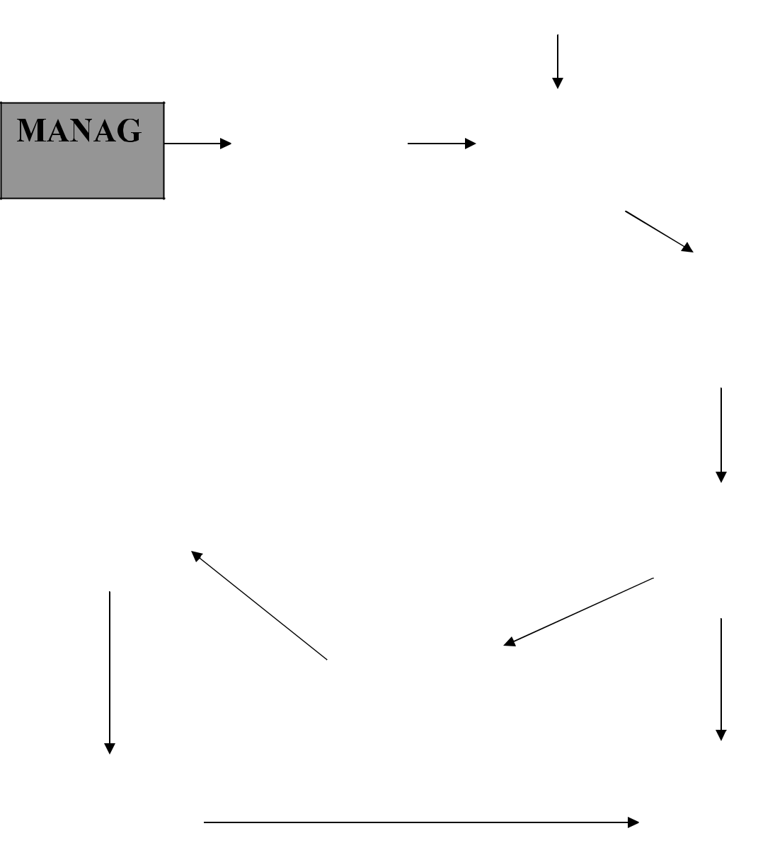

Processing

3 Copy

Selected

Record

4

Compute

Total

|  |  |  |
| --- | --- | --- |
| 5 |  |  |
| Select | Output |  |
| Record |  |
|  |  |

8 Generate

Total List

Final Output

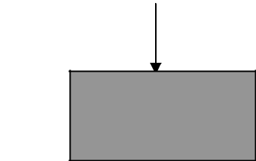

To Screen/Printer

**OUTPUT**

**UNIT**

**SCREENSHOTS**

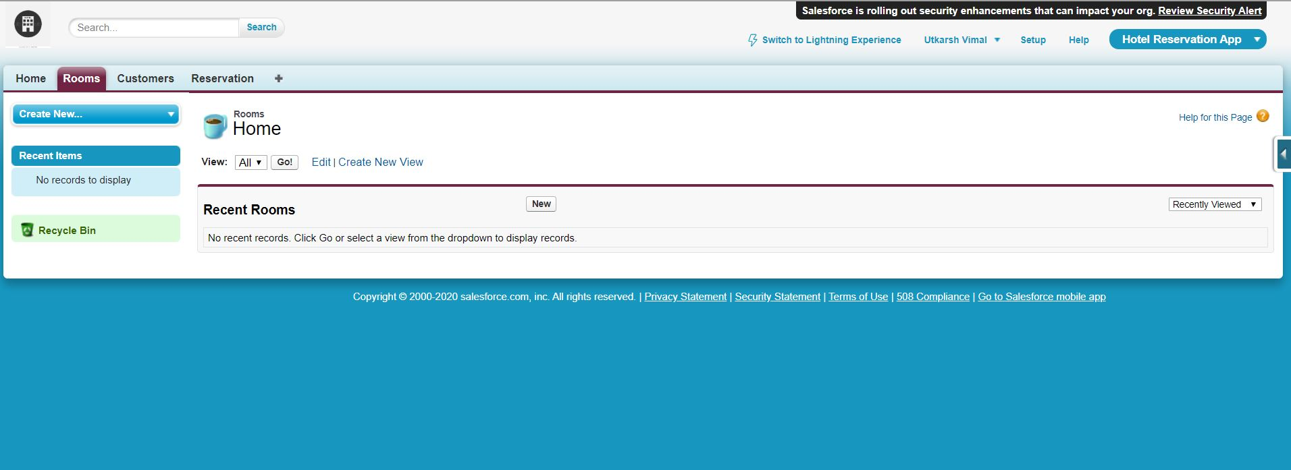

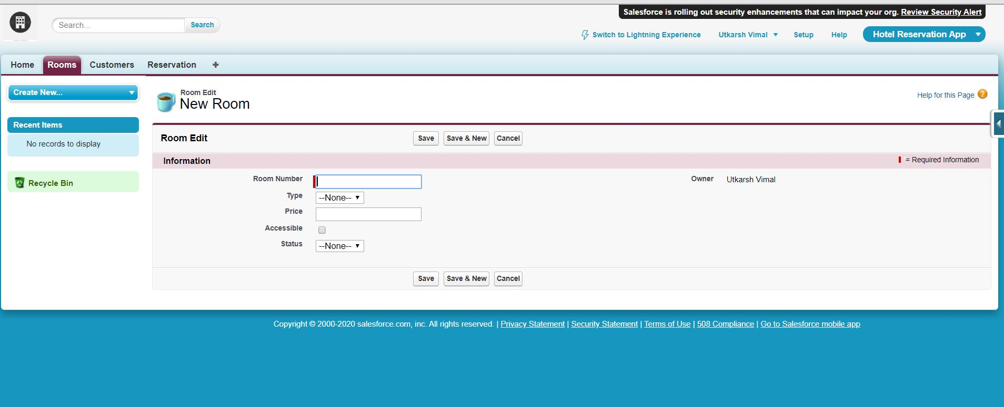

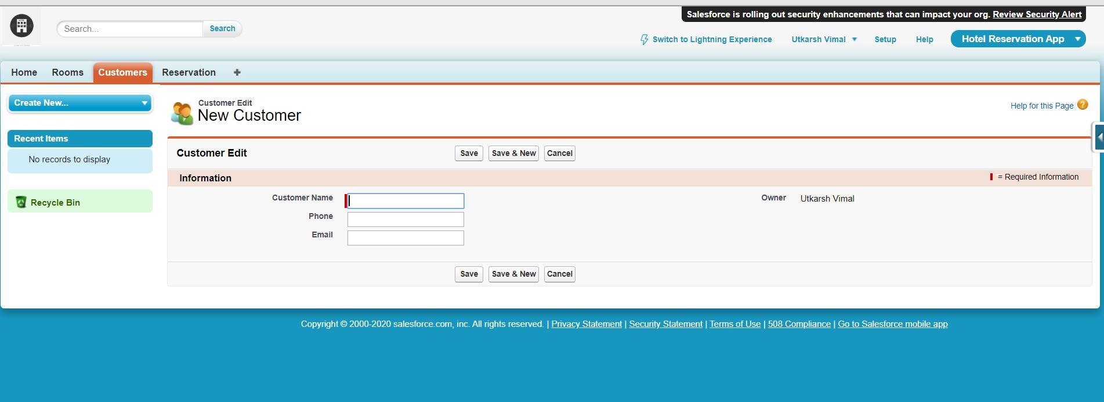

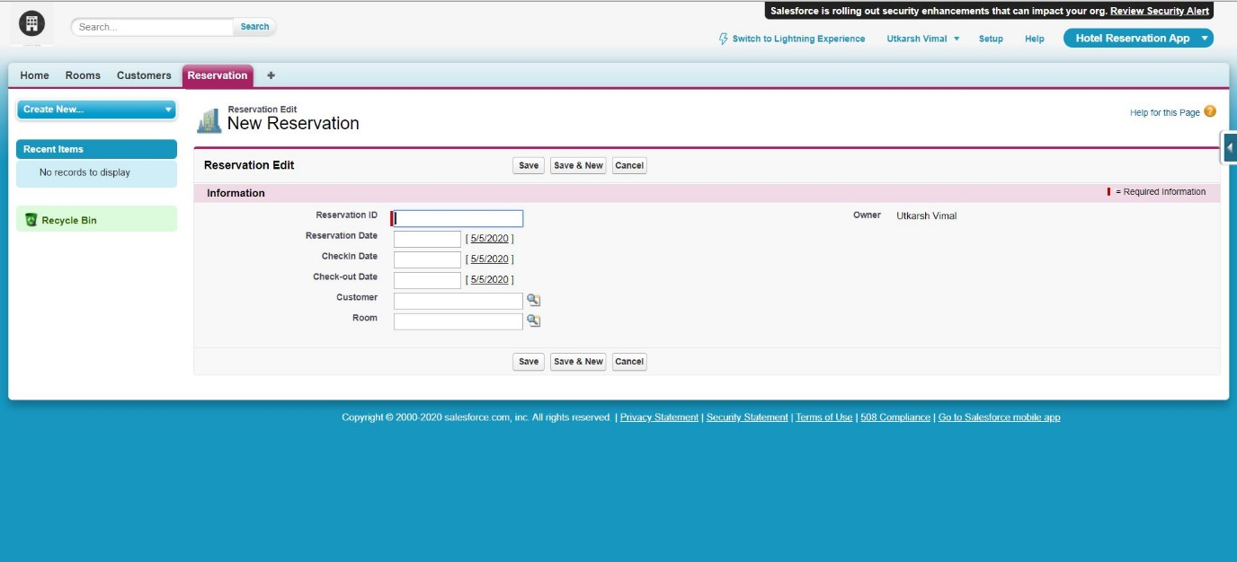

# Approach

-

* + Online:

[www.google.com](http://www.google.com/) [www.wikipedia.com](http://www.wikipedia.com/) [www.SalesforceCommunity.com](http://www.salesforcecommunity.com/) [www.Salesforce.com](http://www.salesforce.com/)

* + Books:

Cetpa book of Salesforce Salesforce book of Vasvani

Informatics practices by Sumita Arora

* + Faculty:

Mr.Pankaj Sharma Sir